# **Code-Inspection**

**Members:**

* Albin Arias Tigsi
* Pedro Vera Garcia
* Victor Alvarado Araujo

GROUP 1

**Part 1: Install Maven for Eclipse**

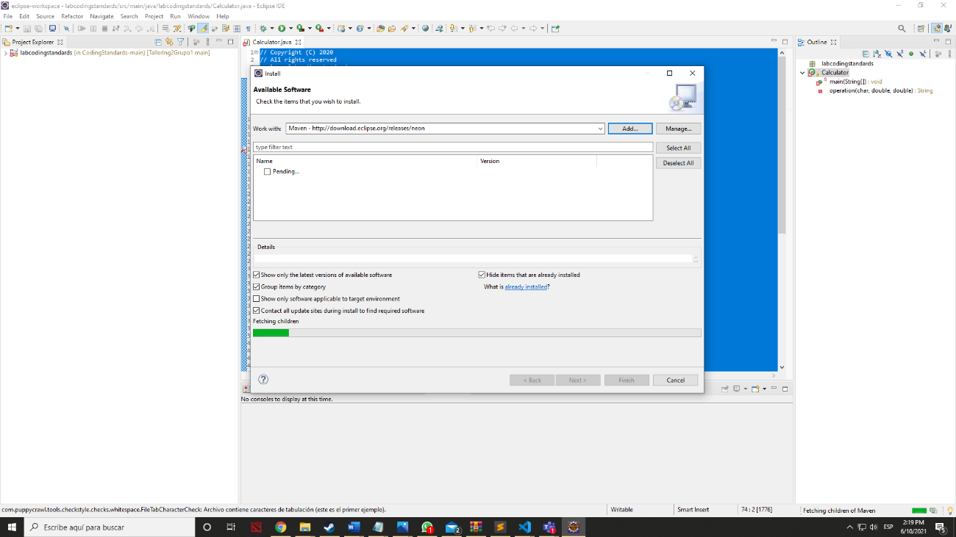

### Part 2: Install the Eclipse PDM plug-in

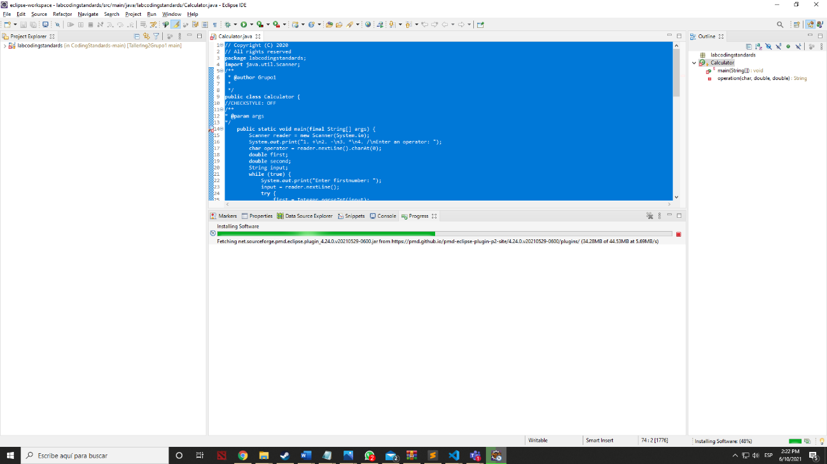

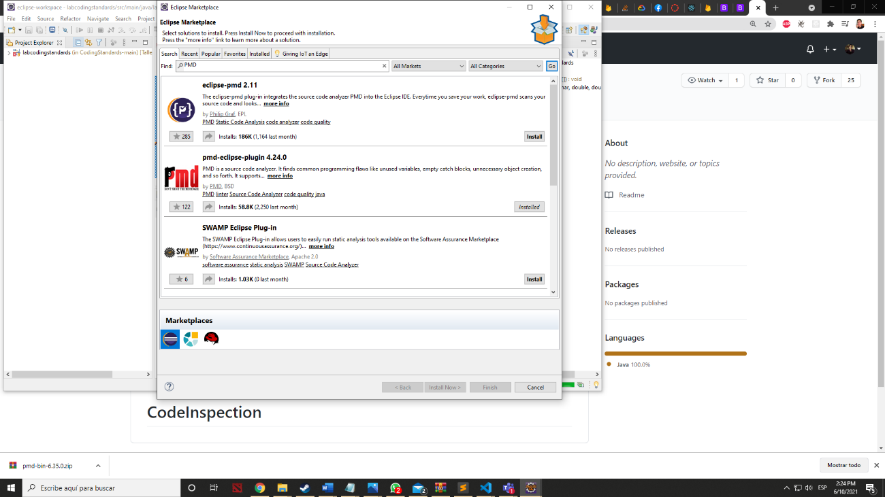

### Part 3: Download and configure the project.

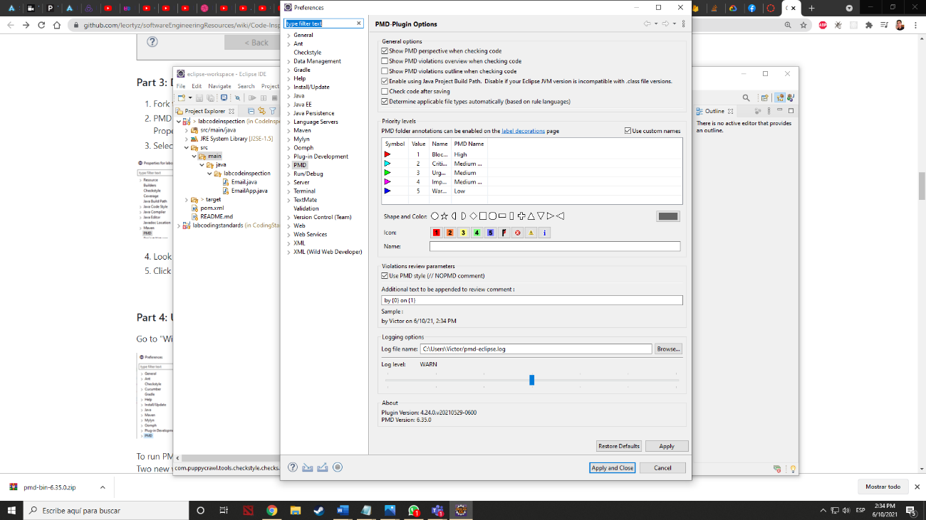

### Part 4: Using PMD

### 

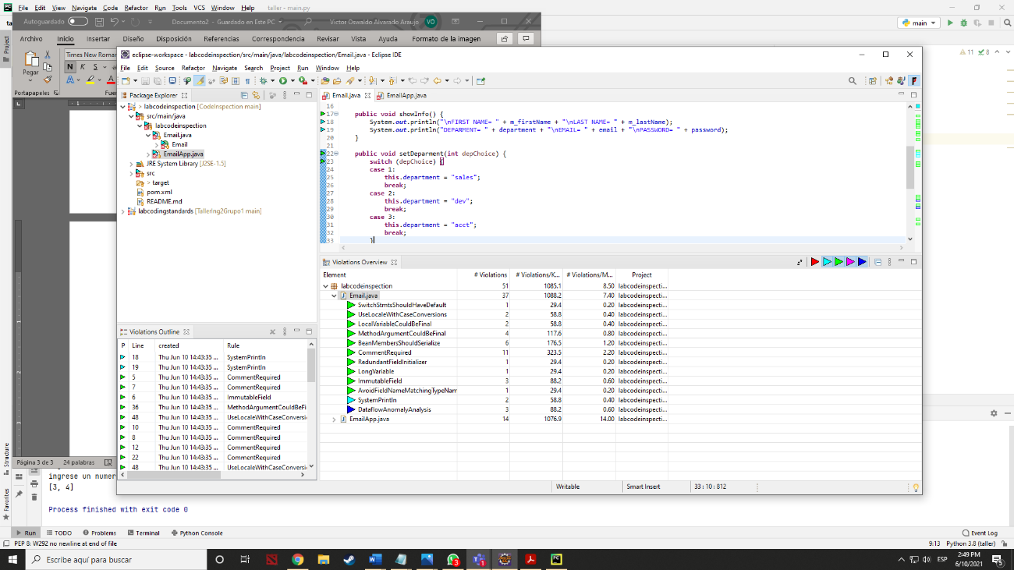

### Part 5: Creating PMD rulesets

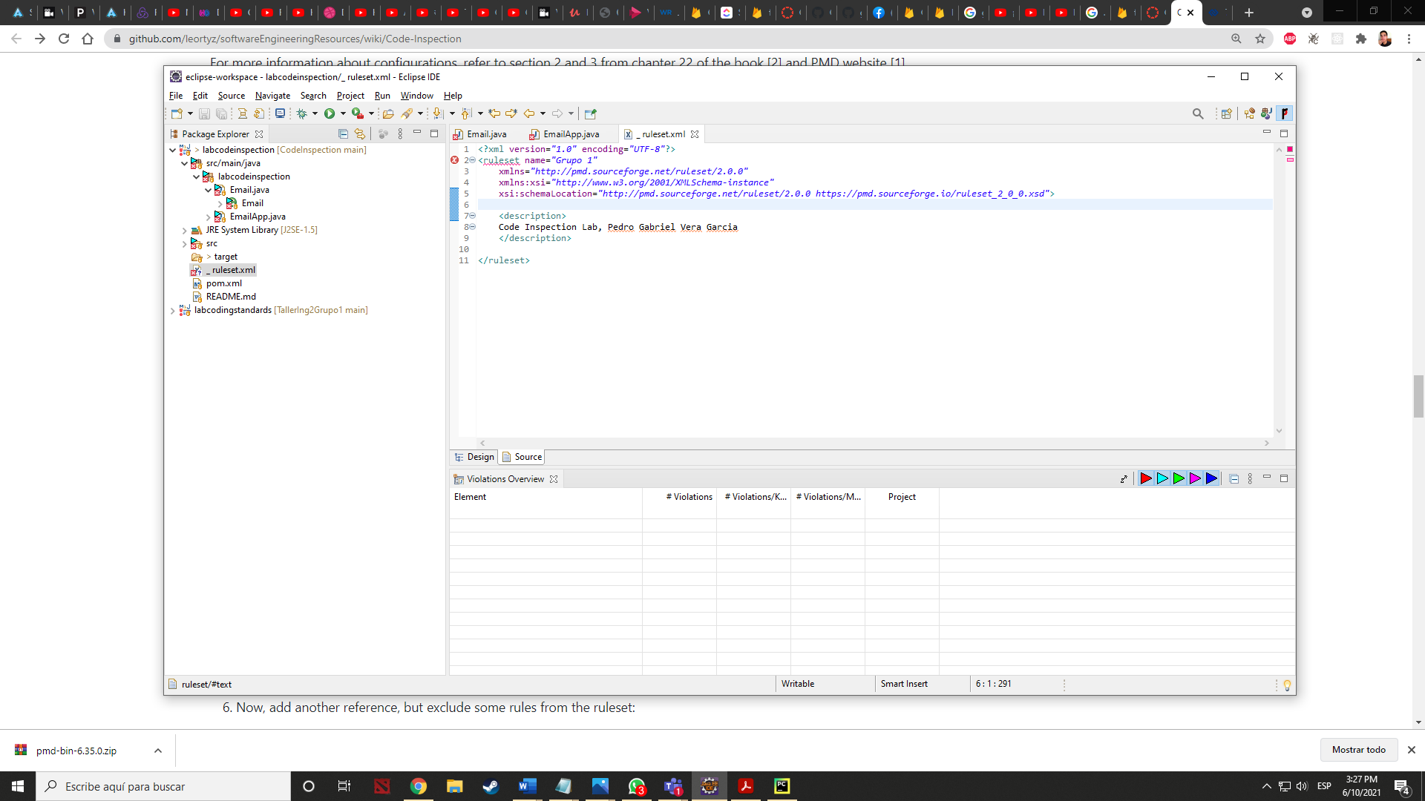

### Part 5 PMD rules in XML file

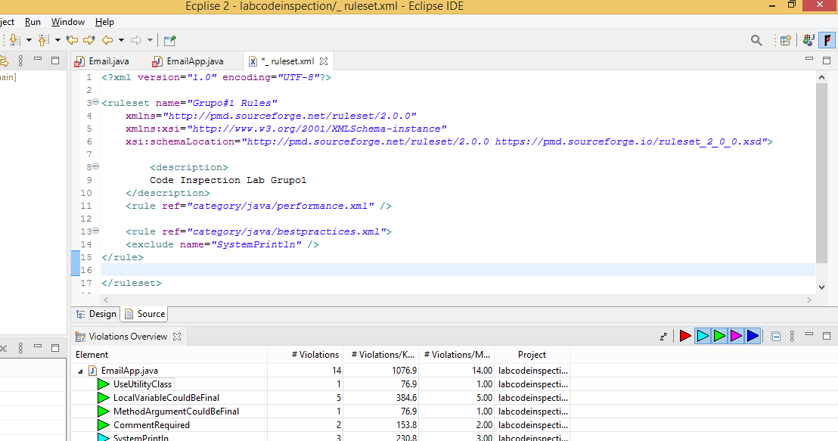

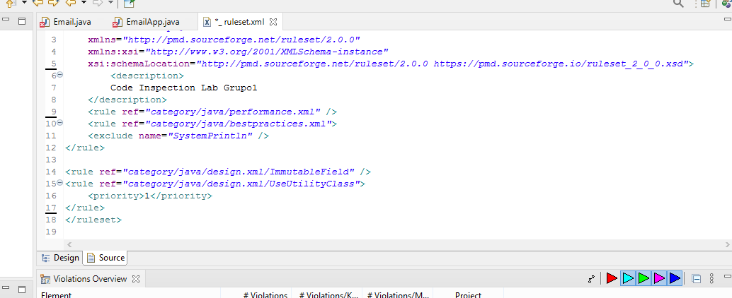

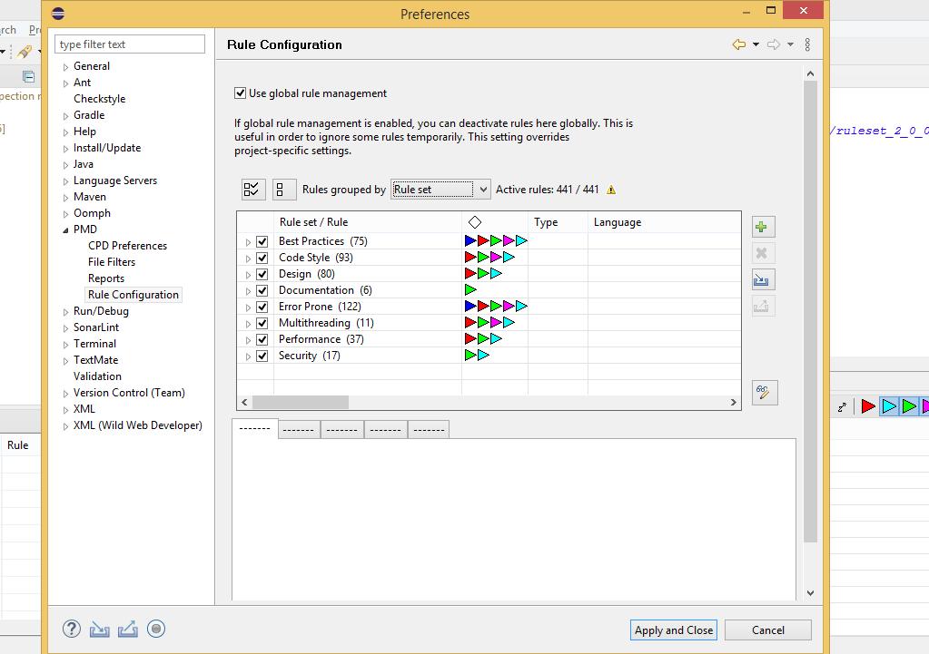

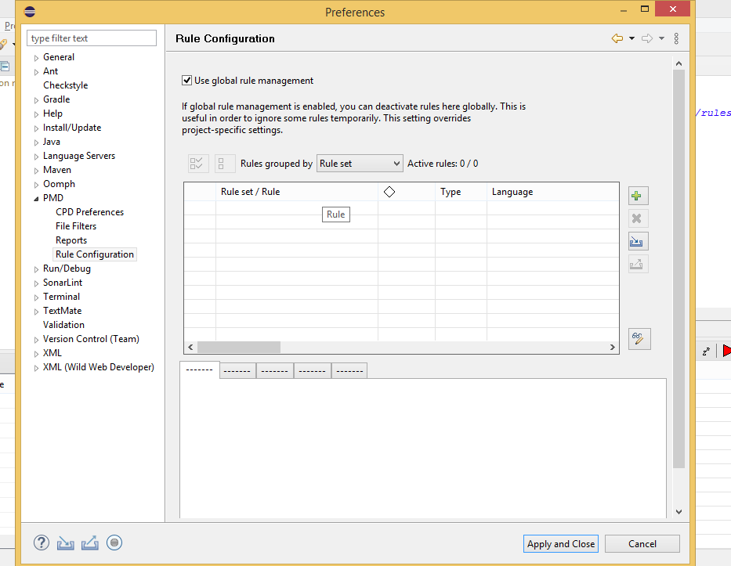

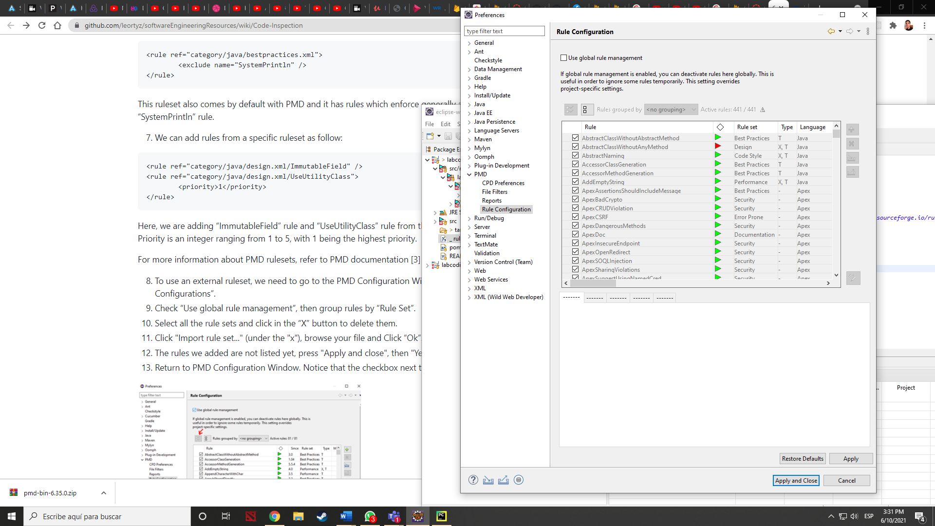

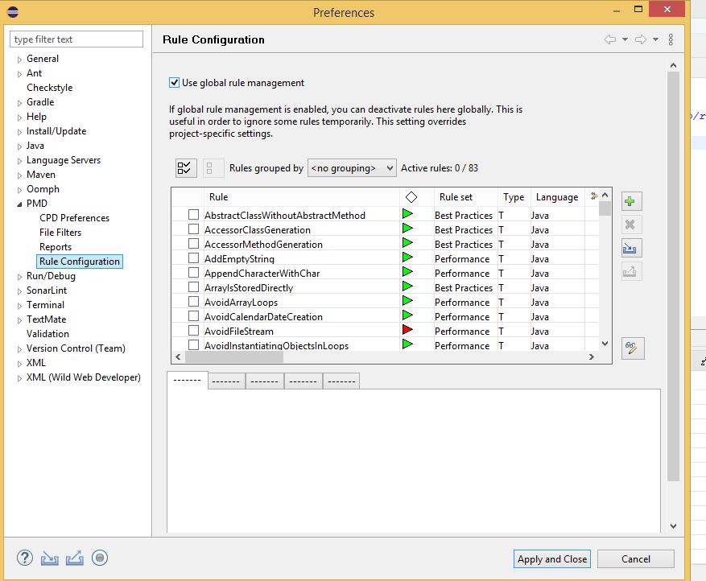

Importar archivo xml

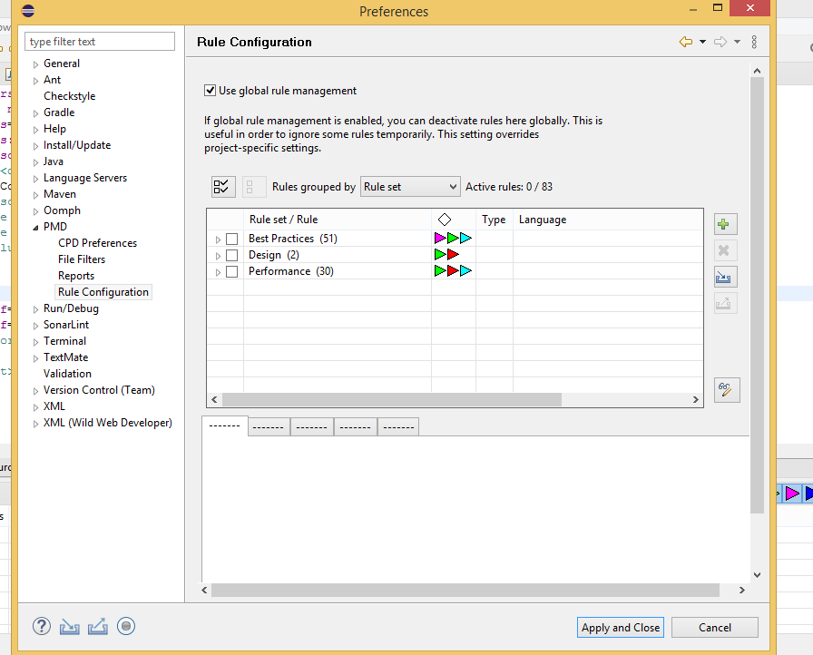

Limpiar Violaciones y Verificar Código.

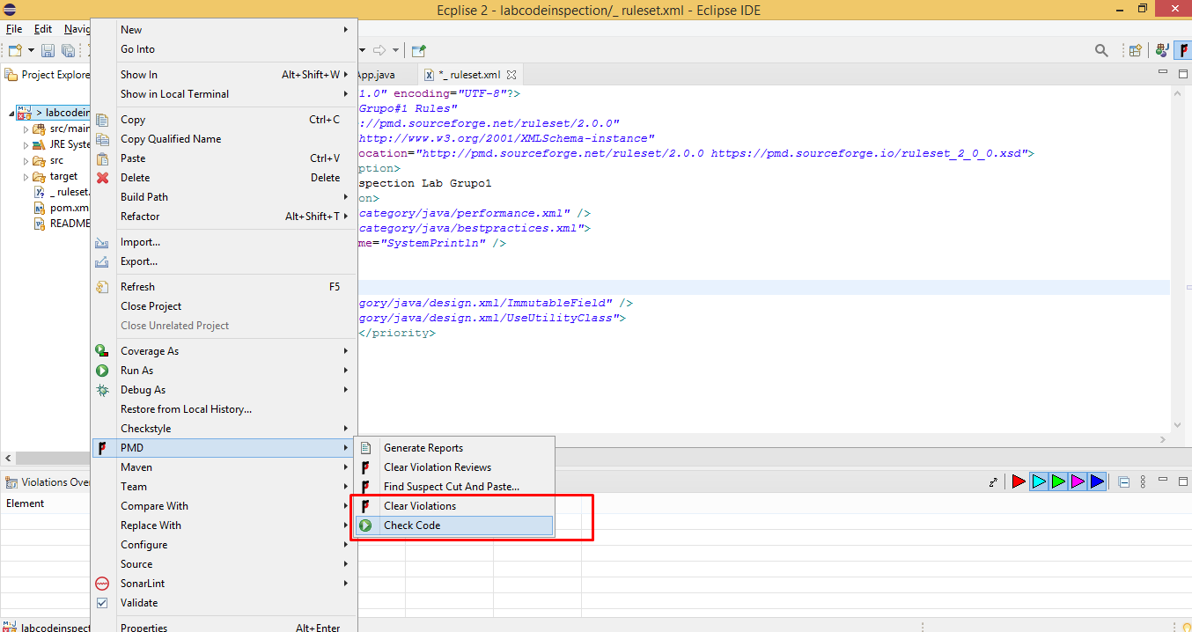

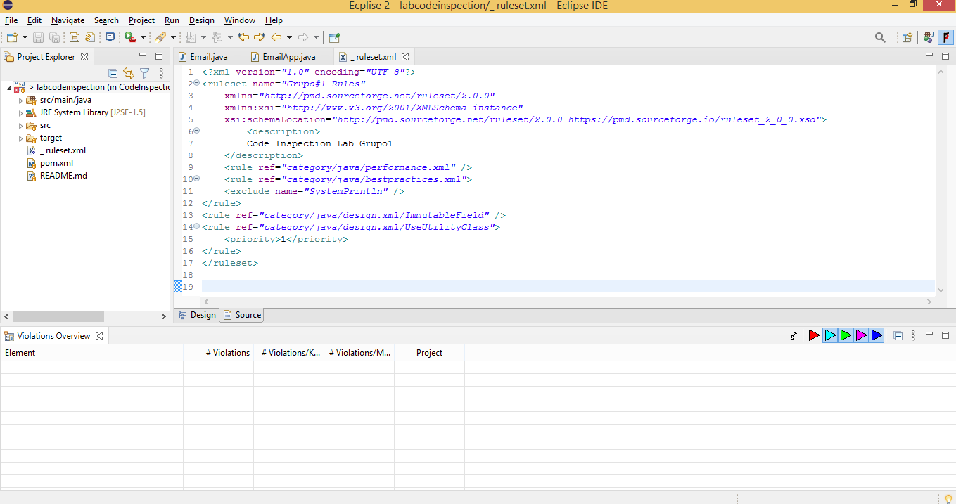

### Part 6: Generating a PMD report

### 

### 

### Part 7: Suppressing PMD Rules

### 

### 

### Parte 8: Detección de cortar y pegar con CPD

### 

### Part 9: PMD and Maven

### 

### 

### 

### 

### URL DEL REPOSITORIO

### <https://github.com/albinisma96/InspectCodigo2-taller10062021->

### <https://github.com/VictorAlvaradoAraujo/taller2Ing2.git>